sin (A±B) = sin(A)cos(B) ± cos(A)sin(B)

**T1 x rn–1 = T0 x rn**

cos (A±B) = cos(A)cos(B) ∓ sin(A)sin(B)

tan (A±B) = $\frac{\tan\left(A\right)±tan⁡(B)}{1∓\tan\left(A\right)tan⁡(B)}$

**The graph of $y=\sin{(ax+b)}$ is shown below, where $a$ and $b$ are positive constants.**

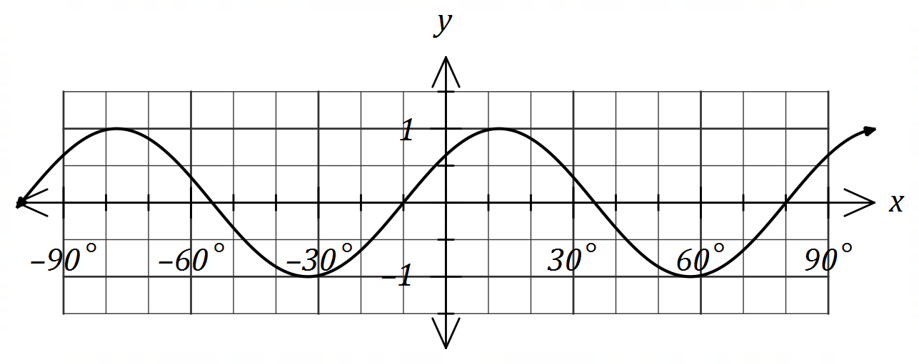

**Determine the minimum possible value of each of the constants.**

a = 4

$\frac{b}{4}$ = 10 → b = 40°

**Note: Use discriminant to prove there are no solutions if you can’t factorise.**

For tree diagram questions with “actually and “classified”, do “actually” and then “classified”.

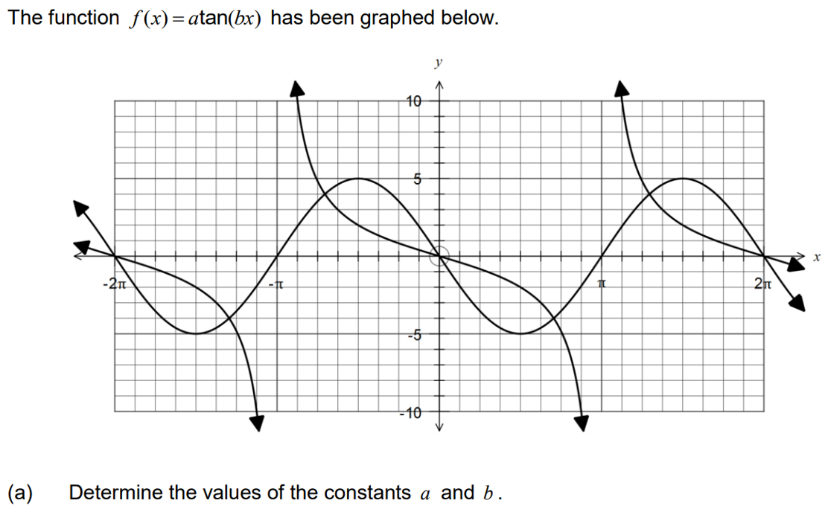

b = $\frac{1}{2}$

( $\frac{π}{2}$, –2) → –2 = a tan( $\frac{1}{2}$ x $\frac{π}{2}$)

–2 = a tan($\frac{π}{4}$) → a = –2

**OR**:

b = $–\frac{1}{2}$

( $\frac{π}{2}$, –2) → –2 = a tan( $–\frac{1}{2}$ x $\frac{π}{2}$)

–2 = a tan($–\frac{π}{4}$) → a = 2

**The diagram shows five congruent semicircles standing on the inside of a regular pentagon with sides of length 20 cm. M is the midpoint of the side AB and P is the point of intersection of two semi-circles.**

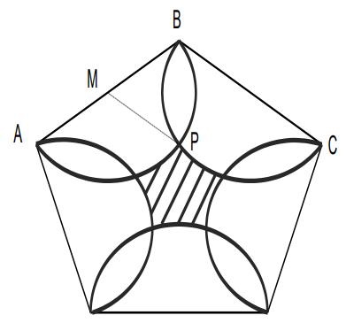

θ

**a) Show that the size of angle ∠BMP = 72°.**

B

θ

2cm

2cm

C

M

P

r = BM = 2cm

θ = $\frac{540}{5}$ = 108°

∠BMP = $\frac{360–2(108)}{2}$ = 72°

**b) Determine the area of the central shaded region.**

Area(1 segment) = (22) – (22)sin() = 0.611cm2

Area(semicircle) – area(4 segments) = 2 – 4(0.611) = 3.84cm2

Area(pentagon) = = 247.75cm2

Area(shaded) = 247.75 – 5(3.84) – 5(0.611) = 225.50cm2

**A right circular cone of base radius $10$ cm and height $25$ cm stands on a horizontal surface. A cylinder of radius $x$ cm and volume cm3 stands inside the cone with its axis coincident with that of the cone and such that the cylinder touches the curved surface of the cone as shown.**

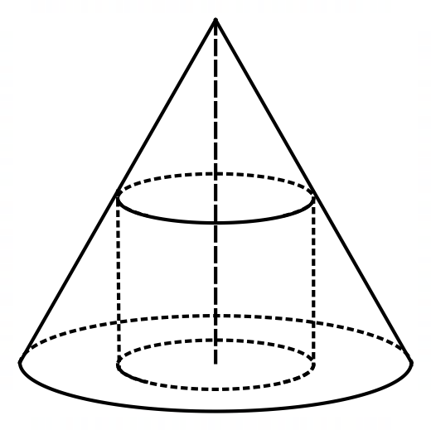

Show that $V=25πx^{2}-2.5πx^{3}$.

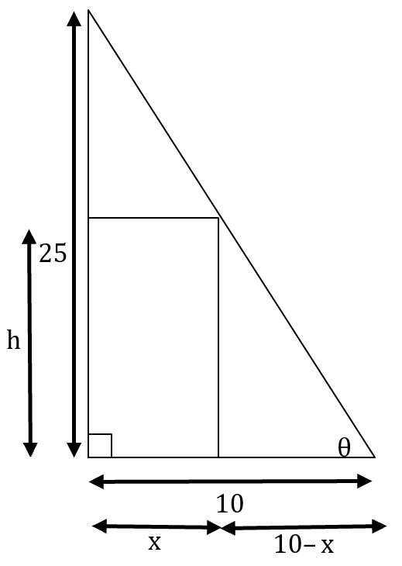

tanθ = $\frac{25}{10}$ = $\frac{h}{10–x}$ → h = $\frac{25(10–x)}{10}$ = $\frac{250–25x}{10}$ = 25 – 2.5x

V = πx2h = πx2(250 – 2.5x) =



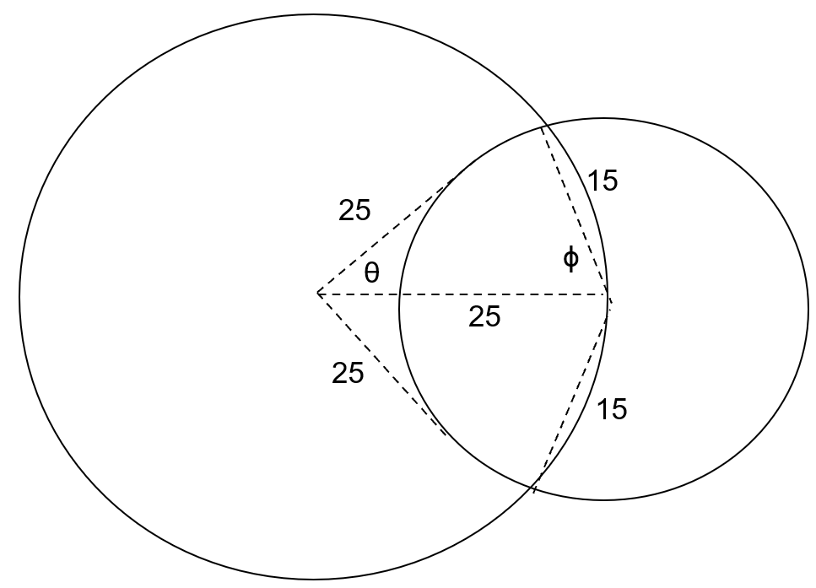

152 = 2(252) – 2(252)cosθ → θ = 0.609 radians → 2 x 0.609 = 1.219

A1 = (252)1.219 – (252)sin1.219 = 87.53cm2

252 = 152 + 252 – 2(15)(25)cosϕ → ϕ = 1.266 radians → 2 x 1.266 = 2.532

A2 = (152)2.532 – (152)sin2.532 = 367.47cm2

Area = A1 + A2 = 308.01cm2

**A drone is flying in a straight line and at a constant height $h$ m above a level pitch towards a thin goal post. It maintains a constant speed of ms-1.**

**Initially, the angle of depression from the drone to the base of the post is $8°$. Exactly $3$ seconds later this angle has increased to $10°$.**

**a) Sketch a diagram to show the two angles of depression from the drone to the base of the post.**

z

13.5m

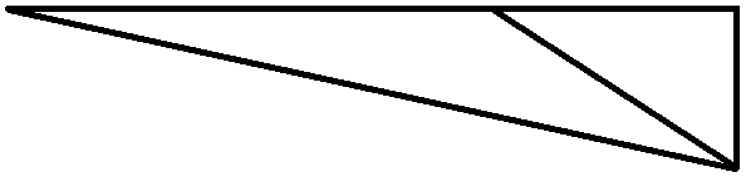

2°

170°

y

h

8°

10°

**b) Determine, showing all working, the value of $h$ and calculate the time after leaving its initial position that the drone will collide with the post.**

$\frac{13.5}{sin2}$ = $\frac{y}{sin8}$ → y = 53.84m

sin10 = $\frac{h}{53.84}$ → h = 9.35m

cos10 = $\frac{z}{53.84}$ → z = 53.02

t = 3 + $\frac{53.02}{4.5}$ = 14.78 seconds

**A diagnostic test for a disease has a $97\%$ chance of giving the correct outcome and it is known that $0.5\%$ of all sheep on a station have the disease. It can be assumed that the correct outcome of the test is independent of whether a sheep has the disease.**

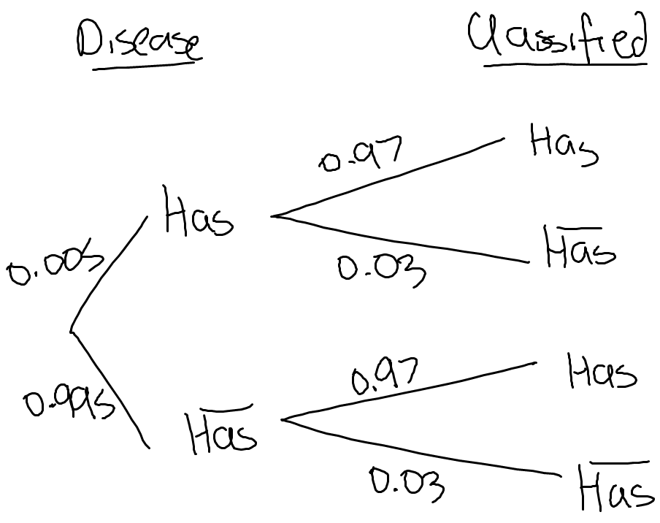

**b) Two sheep are randomly selected for the test from those on the station. Determine the probability that just one of the sheep is diagnosed correctly.**

0.97 x 0.03 x 2 = 0.0582

**Line A and Line B in the x-y plane intersect at 90° at the origin. Line A has a slope of $\frac{1}{3}$. Point (2,–6) is the midpoint of line segment CD which is parallel to Line A. Given that the x-value of C is –1, find the coordinates of point D.**

2 = → x = 5

= –6 → y2 + y1 = –12

= = = → y2 – y1 = 2

y2 + y1 = –12

P(D) = (5, –5)

2y2 = –10 🡪 y2 = –5

y2 – y1 = 2

Use gradient: = → y2 – y1 = 2 → –5 – y1 = 2 🡪 y1 = –7 → P(C) = (–1, 7)